The One With Chandler’s Dad

Teleplay by: Brian Buckner & Sebastian Jones
Story by: Greg Malins
Transcribed by: Eric Aasen
722 钱德之父
瑞秋发现莫妮卡让所有人开她的保时捷，惟独不给自己；
当罗斯拿着车钥匙时，瑞秋偷了钥匙，载罗斯去兜风。
钱德说他没有邀请父亲参加婚礼；于是莫妮卡计划去拉斯维加司找钱父，促使父子俩和好。
乔伊发现菲比的男友Jake穿着菲比的内裤；菲比向乔伊解释说这是Jake阳刚气的表现。
乔伊打算也试试，结果过了头。
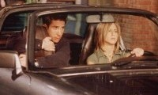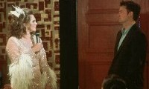
7.22 The One With Chandler's Dad
Rachel finds out she's the only one whom Monica doesn't let drive the Porsche;
when Ross has the keys she steals them and takes Ross for a joy-ride.
Chandler reveals that he hasn't invited his Dad to the wedding;
Monica arranges a trip to Las Vegas, where his father performs, so they can reconcile(vt.使和解).
Joey discovers that Phoebe's boyfriend (Jake) is wearing Phoebe's underwear;
Phoebe tells Joey that it's a sign that Jake is secure in his masculinity.
Joey decides to try it out, but takes it a bit too far. [Scene: Monica and Chandler's, Phoebe, Monica, and Rachel are sitting around the kitchen table]
Monica：I think I'll go with the chicken piccata instead of the Cornish game hen.
piccata n.<烹>(用柠檬 黄油调味的)嫩煎小牛肉片 香溜肉片/Conish n.(英国)考尼什(雏)鸡/A Cornish game hen, sometimes simply called a game hen or a Cornish rock , is an immature(adj.未长成熟的) chicken of the Cornish variety, or of a crossbreed(<生>杂种) between the Cornish chicken and another breed. The Rock Cornish game hen, the most common game hen crossbreed, is a crossing with the Rock chicken. As is common in the poultry(n.家畜) industry, storebought(adj.店铺外售的) game hens may be either male or female specimens, despite the common usage of the word "hen" typically denoting a female.The Rock Cornish game hen was originally bred by Jacques and Alphonsine Makowsky in Connecticut in 1950. By crossbreeding the short-legged, plump(adj.圆胖的)-breasted Cornish chicken with various other chickens (including the White Plymouth Rock variety) and game birds, the result was a small bird with all white meat, enough for a single serving. Originally marketed as a temporary substitute for a flock of guinea hens that the farm lost in a fire, it soon became more popular than the guinea(n.几内亚) hen.Despite the name, game hens are not hunted as a game(n.猎物) animal, and are instead raised in chicken coops(n.鸡笼) as are normal chickens. They are, in fact, chicks that are fed a highly nutritious diet and slaughtered four to five weeks from hatching.The U.S. Department of Agriculture requires that all chickens sold as Cornish game hens be no more than 2 pounds in ready-to-cook weight.The birds are often prepared by baking in the oven whole, with spices or seasonings(n.调料) added to taste. This image depicts a cornish game hen prepared with the popular spice Rosemary(n.迷迭香)
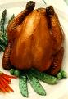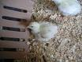
chicken piccata
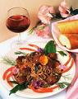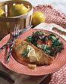
Phoebe: Will there be a vegetarian option, you know, for me?
Monica: Yes. Definitely.
Phoebe: Oh great, What is it?
Monica: Dancing.
Ross: (entering) Hey!
Monica: Hey!
Ross: Hey uh Mon, I saw the Porsche parked out front, can I get the keys? Thought I’d take that bad boy out for a little spin.
spin <口>(汽车等的)疾驰 兜风[eg: Get your bicycle and come for a spin]
Rachel: Wait a minute! (To Monica) You let Ross drive the Porsche and when I ask you, you say you’re the only one who’s allowed to drive it.
Monica: Yeah, well he’s my brother! And plus he drives so slow he could never hurt it.
Ross: It’s a car Monica! Not a rocket ship!
rocket ship

Monica: Whatever Ross! Just replace the bulbs in the brake lights after you’re done.
brake light
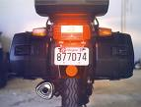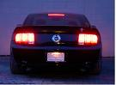
Joey: (entering) Hey!
Ross: Hey!
Phoebe: Hey!
Joey: Saw the Porsche out there Mon, lookin’good. When do I get to take that baby out again?
Rachel: (shocked) You let Joey drive it?!
Phoebe: I’ve never driven it! Okay? Not once! Okay once. Okay, I drive it all the time.
Monica: Nice work everybody! So much for the y’know, "You can drive it, but don’t tell Rachel" plan!
Rachel: Wow! I can’t believe you lied to me.
Phoebe: Okay, I can fix this! Okay Monica, Rachel thinks all you can talk about is the wedding. (Rachel glares at her.) There Ok, I've blown both your secrets. Now we're even.
blow one’s secret 泄露某人的秘密
Monica: Great! Well Rachel, the reason why I won’t let you drive the Porsche is because you’re a terrible driver. There! That wasn’t about the wedding.
there adv.(用以引起注意 加强语气等)瞧 你看[eg: There she is]
Ross: Look Rach if-if you want to go for a ride in the Porsche I’ll be glad to take you for a quick spin around the block.
Joey: Yeah, you got a couple hours?
Opening Credits
[Scene: Central Perk, Rachel is there as Ross enters with all his hair sticking straight up.]
Ross: Whew! That was a brisk ride!
brisk adj.轻快的 活泼的
Rachel: Take the top down did ya?
Ross: Only way to fly.
(Rachel laughs.)
Rachel: Come on Ross give me the keys! Monica does not know what she’s talking about! I am an excellent driver!
Ross: You’re fast and irresponsible. That adds up to a bad driver.
Rachel: Well in High School, that added up to head cheerleader.
(A woman walks by and smiles at Ross’s hair.)
Ross: Did you see the look that girl just gave me? Huh? She must’ve seen me cruising in the bad boy.
cruise vi.(出租车 警车等)缓慢巡行[eg: The taxi was cruising down the street in search of passengers]
Rachel: I think she’s checking out your beehive Ross.
beehive n.蜂窝 蜂窝状发型/hive n.蜂房
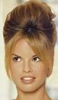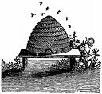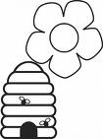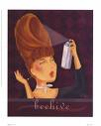
Ross: What?! (Checks his hair.) Give-give me a brush.
Rachel: Gimme the keys!
Ross: No way!
Rachel: Well no brush!
Ross: Fine! Y’know what? It doesn’t matter, because, if I remember correctly, there is a comb on the floor of the bathroom.
(He goes to the bathroom and after he leaves Rachel goes through his coat and grabs the keys along with a $20 bill. The woman from before watches her do this.)
Rachel: (to the woman) Alimony. (Runs outside.)
alimony <律>赡养费 生活费 抚养费
[Scene: Monica and Chandler's, Monica and Phoebe are counting the invitations as Chandler exits from the bathroom.]
Monica: Chandler, we still haven’t gotten an RSVP from your dad.
RSVP <法>Acronym(n.只取首字母的缩写词) of French phrase: " Répondez S'il Vous Plaît". English translation: "Reply If You Please"
Chandler: Oh! Right. Umm, maybe that’s because I didn’t send him an invitation.
Monica: Why not?
Chandler: An invitation? That's like almost asking him to come.
Monica: Chandler! He’s your father; he should be at our wedding.
Chandler: I was gonna send him an invitation but then I saw the stamp.It was one of those Marilyn Monroe stamps and I thought: My dad has that dress.
Marilyn Monroe (born Norma Jeane Mortenson; June 1, 1926 – August 5, 1962), was a Golden Globe Award-winning American actress, singer, model, pop icon and sex symbol(n.性感演员). She was known for her comedic skills and screen presence, going on to become one of the most popular movie stars of the 1950s and early 1960s. At the later stages of her career, she worked towards serious roles with a measure of success. However, she faced disappointments in her career and personal life during her later years. Her death has been subject to speculation and conspiracy theories.
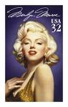
Phoebe: Wow. That must be a very different view when he stands over an air vent.
air vent n.通风孔
Chandler: You should see him singing 'Happy Birthday, Mr. President.'
"Happy Birthday, Mr. President" is a variant on the traditional "Happy Birthday to You" song. This version was originally sung by Marilyn Monroe to then(adj.当时的)-President of the United States, John F. Kennedy.
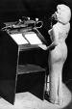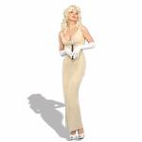
Monica: We have to invite him.
Chandler: I don’t even know the man. Okay? We’re not that close. I haven’t seen him in years.
Monica: Well what are you gonna do when he finds out he wasn’t even asked?!
Chandler: Well he doesn’t have to know! It’s not like we run in the same circles. I hang out with you guys, and he stars in a drag show in Vegas.
circle n.生活圈子/A Drag queen is usually a man who dresses (or "drags") in female clothes and make-up for special occasions and usually because they are performing or entertaining as a hostess, stage artist or at an event. This is in contrast to those who cross-dress for reasons other than as a source of entertainment for others or transgendered people who are not necessarily drag queens or cross-dressers but sometimes fit into those labels.There are many kinds of drag artists and they vary greatly from professionals who have starred in movies to people who just try it once. Drag queens also vary by class and culture and can vary even within the same city. Although many assume all drag queens are gay men or transgendered, there are drag artists of all genders and sexualities who do drag for various reasons. Generally, drag queens dress in a female gender role, often exaggerating certain characteristics for comic, dramatic or satirical(adj.讽刺的) effect. Other drag performers include drag kings, who are women who perform in male roles, faux(<法>假的 人工的) queens, who are women who dress in an exaggerated style to emulate(v.仿效) drag queens and faux kings, are men who dress to impersonate(v.模仿) drag kings.The term "drag queen" usually refers to people who dress in drag for the purpose of performing, whether singing or lip-synching(n.对口形) dancing, participating in events such as gay pride parades, drag pageants(n.游行 盛典), or at venues such as cabarets[n.(有音乐 歌舞表演的)酒店 酒店的歌舞表演] and discotheques(n.迪斯科舞厅). In the United Kingdom, alongside traditional drag work such as shows and performances, many drag queens engage in 'mix-and-mingle' or hosting work at night clubs or at private parties/events. Drag is a part of Western gay culture; it is often noted that the Stonewall riots(n.暴动 骚乱) on June 27, 1969 in New York City were inspired and led by drag queens, and, in part for this reason, drag queens remain a tradition at pride events. Prominent drag queens in the gay community of a city often serve as official or unofficial spokespersons, hosts or emcees, fund-raisers, chroniclers and community leaders.人妖
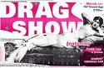
Phoebe: Ooh, I think I wanna trade circles.
trade vt.对换
Chandler: Trust me, you don’t want him there either. Okay? Nobody is gonna be staring at the bride when the father of the groom is wearing a back-less dress.
back-less dress n.露背装
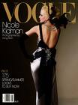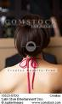
Monica: So what! As long as he’s not wearing a white dress and a veil I don’t care.
Phoebe: Okay, I think I need to do some shopping. (Gets up and leaves.)
[Scene: A Street, Rachel is throwing her coat into the Porsche and getting in.]
Rachel: Ahhh! (Gets in.) Ooh, nice!
(Suddenly from out of nowhere Ross dives onto the hood.)
Rachel: My God!
Ross: What do you think you’re doing?!
Rachel: Just washing the windshield. (She turns on the wipers forcing Ross off of the hood.)
wiper n.擦windshield的雨刷/hood<美>(汽车的)车盖[eg: At the gas station they raised the hood of our car to put oil in the engine]
Ross: There is no way I am letting you drive this car!
Rachel: Couldn't find the comb?
Ross: No. So why don’t you just hand over the keys?
Rachel: Oh.
{Transcriber’s Note: She puts the key into the ignition, which is on the left side of the steering wheel. Does anyone know why that is? It’s a tradition left over from Porsche’s racing history. The world’s greatest endurance race is the 24 Hours of LeMans. Which is in France and runs for 24 hours straight from noon on Saturday through the dark of night and finishes at noon on Sunday. In the 60s LeMans had a unique start where the drivers would actually start the race outside of the car and across the track. At the start of the race, the drivers would run across the track, get in the car, buckle up, start the car, and drive off. Porsche wanted to reduce the amount of time that took. Since all cars to that point had the ignition switches on the right side of the steering wheel, that required the drivers to use their right hand to grab the seat-belts, put the car in gear and start it. The driver’s left hand did nothing. Porsche in order to save a few seconds in a 24-hour race; moved the ignition switches to the left side of the steering wheel so that the driver could start the car with his left hand while grabbing the seat-belts with his right hand. That’s why every Porsche car built since then has the ignition on the left side of the steering wheel.}
endurance race n.长距离赛/the 24 Hours of LeMans：法国勒芒24小时汽车耐力赛。法国勒芒24小时汽车大赛是与摩纳哥大奖赛(MONACO GRAND PRIX)，美国印地(INDY)和戴托那(DAYTONA)500齐名的久负盛誉的世界汽车比赛。它以超长的比赛时间著称，车手连续驾车24小时，使比赛之日成为一年中最长的一天/buckle up v.扣上安全带
Ross: No ah-ah-ah! Do not start this car! (She starts the car.) Okay! Okay! I will give you twenty bucks if you get out of this car right now! (He looks for the twenty Rachel stole and doesn’t find it.)
Rachel: Look Ross, if you’re so freaked out, just get in the car!
Ross: With you?! Yeah right!
Rachel: All right. (She starts off.)
Ross: (grabbing the car) Okay! Okay! Okay! (He gets in, but into the back seat.)
Rachel: What are you doing?! Get in the front!
Ross: In the death seat?!!
驾驶座旁边的那个位置的确是名副其实的death seat
Rachel: Oh my…
(They drive off.)
[Scene: Central Perk, Joey and Phoebe are on the couch as a man enters.]
Man: Hey guys!
Joey: Hey!
Phoebe: Hey sweetie!
Man: Ready to go?
Phoebe: Yeah! Sure! Ooh, I left my purse up at Monica’s. I’ll be right back. (She goes to get it.)
Man: (stopping her) Wait a minute!
Phoebe: What? (He leans in to kiss her.) Oh. (They kiss and Phoebe pauses.) Ooh. (Pause) Whoa! That one kept going. (Exits.)
Joey: So! You and Phoebe huh? How long have you been going out?
Man: Over a month.
Joey: Wow! Maybe uh, maybe you and I ought to get to know each other a little better.
Man: Sure, I’d like that.
Joey: So uh, what’s your name?
Man: (laughs) It’s Jake.
Joey: Joey. (They shake hands.) Hey Jake, do you like the Knicks?
Jake: Yeah, big fan.
Joey: Me too! There’s a game on Tuesday do you wanna go?
Jake: Yeah that would be great! Let me make sure I’m not doing anything Tuesday. (He bends over to open his bag, when he does so his pants slide down his butt revealing a pink lace secret.)
pink lace
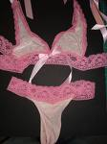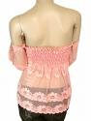
[Scene: Monica and Chandler's, Monica is entering from the bedroom carrying two bags of luggage.]
Monica: Here! (She sets a bag down in front of him.)
Chandler: What’s this?
Monica: It’s your suitcase. We’re going to Las Vegas.
suitcase n.衣箱
Chandler: Are you serious?! I mean like eloping?! No more stupid wedding stuff?! No more these flowers or these flowers or these flowers—Think of the money we’ll save!! (Monica just looks at him.) We’re not eloping. I love the flowers. Can our wedding be bigger please?
elope vi.私奔[eg: She eloped with her lover]
Monica: We’re going to Las Vegas to see your dad. It’s time you two talked, and I want to get to know my father-in-law.
father-in-law n.丈人
Chandler: Y’know we already went over this and I won!
Monica: No you didn’t. Oh and honey just so you know, now that you’re marrying me, you don’t get to win anymore.
Chandler: Look forget it okay? I don’t want to go. I don’t want to see him. I don’t wanna.
Monica: Chandler, look I-I know that your dad embarrassed you. I know…
Chandler: No-no all kids are embarrassed by their parents, you’d have to come up with a whole new word for what I went through. When I was in High School, he used to come to all of my swim meets dressed as a different Hollywood starlet. Y’know it’s hard enough to be fourteen. You’re skinny. You’re wearing speedoes—That your mom promised that you would grow into! And you look up into the stands and there’s your dad cheering you on dressed as Carmen Miranda. We was wearing a headdress with real fruit that he will later hand out to your friends as a healthy snack!
swim meet n.游泳比赛/starlet <美>刚露头角的年轻女演员 小女明星/stand n.看台/Carmen Miranda：钱德勒在说起童年因父亲变成同性恋而受的伤害时曾经提到过这个人，他说父亲经常穿着得像卡门 米兰达。这是美国四五十年代著名的女演员，以穿着性感服装和水果头饰物知名/Carmen Miranda(February 9, 1909 – August 5, 1955); birth name Maria do Carmo Miranda da Cunha, GCIH) was a Portuguese-Brazilian samba(n. 桑巴舞) singer and motion picture star most active in the 1940s. She was later nicknamed Carmen by her father, because of his love of opera (specifically: Carmen from the opera by Bizet[法国作曲家,生于巴黎,世界上演率最高的歌剧《卡门》的作者]). The "Carmen legacy" was instrumental in synthesizing, divulging(vi.暴露) and popularizing Tropicalismo(n.一种巴西艺术形式)
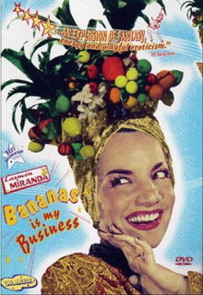
Speedo is a swimsuit manufacturer that began on Bondi Beach near Sydney, Australia. Speedo is currently the world's largest selling swimwear brand and manufactures products for both recreational and competitive swimming. Its trademark is a red boomerang(n.回飞镖)-shaped logo.Today the company is headquartered in Nottingham and is owned by the London based Pentland Group .
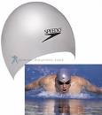
swim meet

healthy snack n.健康食品(多指水果)

Monica: But he was there! My dad didn't come to one of my Brownie meetings.
brownie meeting/ brownie n. (穿棕色制服的 7-8岁的)女童子军
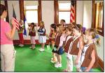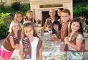
Chandler: You were a Brownie?
brownie <美>巧克力小方饼 果仁巧克力小方块蛋糕

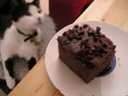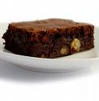
Monica: No. I ate them.Hey, the point is that he was at everyone of your swim meets and he was there cheering you on! Okay? That’s a, that’s a pretty great dad.
cheer sb on v.为某人加油鼓劲
Chandler: He had sex with Mr. Girabaldi!
Monica: Who’s Mr. Girabaldi?
Chandler: Does it matter?!
Monica: Chandler, you’re not fourteen anymore. Okay? Maybe it’s time that you let that stuff go. If your father’s not at your wedding…you’re gonna regret it for the rest of your life.
Chandler: Yeah o-okay, but I’m just doing this for you.
Monica: Yes!
Chandler: So I really never get to win anymore?
Monica: How much did you ever really win before?
[Scene: Central Perk, Phoebe is there as Joey enters.]
Joey: Pheebs!
Phoebe: Hey!
Joey: Listen, you know how uh, when you’re wearing pants and you lean forward I check out your underwear?
Phoebe: Yeah!
Joey: Well, when Jake did it I saw that…he was wearing women’s underwear!
Phoebe: I know. They were mine.
Joey: Oh. (Laughs.) No! No wait, that’s weird!
Phoebe: No, it’s not! We were just goofing around and I dared him to try them on.
goof around <俚>闹着玩/dare vt.挑逗 激[eg: I dare you to cheat me]
Joey: That’s weird!
Phoebe: I’m wearing his briefs right now.
briefs
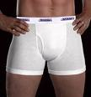
Joey: That’s…kinda hot.
Phoebe: I think so too. And that little flap? Great for holding my lipstick.
flap n.(封)盖口
Joey: Yeah, I wouldn’t know about that.
Phoebe: And! Y’know what Jake says? That women’s underwear is actually more comfortable. And he loves the way the silk feels against his skin.
Joey: Yeah well next thing you know, he’ll be telling you that your high heels are good for his posture!
posture n.(身体的)姿势 姿态
high heels
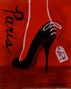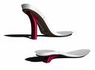
Phoebe: There is nothing wrong with Jake! Okay? He is all man! I’m thinking even more than you.
Joey: Oh yeah, he looked like a real lumberjack in those pink laceys.
lumberjack n.伐木工人/lumber <美>木材/lacey adj.花边的
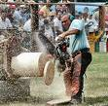
Phoebe: I’m just saying that only a man completely secure with his masculinity could walk around in women’s underwear! I don’t think you could ever do that.
masculinity n.阳刚之气
Joey: Hey! I am secure with my masculinity.
secure adj.有把握的 确定无疑的[eg: Our success is secure]
Phoebe: Okay whatever.
Joey: You’ve seen my huge stack of porn right? (Phoebe nods.)
Gunter：(brings his ordered coffee)Here you go.
Joey: (Phoebe checks out his underwear) Look all you want. There's nothing there.
[Scene: The Porsche, Rachel is driving along a highway and Ross has finally moved to the death seat and is terrified.]
Ross: Slow down, or I am returning to the back seat.
Rachel: Would you calm down?
Ross: No! You're driving 15 miles over the speed limit.
Rachel: I'm driving 5 miles over the limit. They raised it by 1 0.
Ross: What, are they crazy?!
Rachel: God. I forgot how much I love driving. I have got to get my license renewed.
Ross: (shocked) You don’t have a valid driver’s license—Okay that is it! Pull over right now!
valid <律>有效的
Rachel: Oh Ross you’re so tense! You just gotta relax okay? Just need to relax all right? Just need to relax… (She takes her hands off of the wheel.)
tense adj.紧张的
Ross: (grabbing the wheel) What-what are you doing?! Are you—Okay that’s not funny! Just stop horsing around!
horse around <美俚>胡闹
Rachel: I am not horsing around okay? I am Porsching around.
(Suddenly a siren goes off behind them.)
Rachel: Uh-oh. (She starts to pull over.)
Ross: Okay, stay calm. Nothing is going to happen to you, you are not in that much trouble.
Rachel: Really? You think so?
Ross: I was talking to myself! You’re going down!
go down <美口>死定了
[Scene: Joey and Rachel's, Joey is walking from the bathroom to his bedroom and walks past a pile of Rachel’s laundry, which just happens to include a selection of panties. He stops, goes back to the basket, looks for Rachel, picks up a lavender thong, and heads for his bedroom. However, he decides he doesn’t like his selection and goes back this time picking up a red low-cut silk brief and heads for his room, flexing along the way to prove his masculinity.]
lavender adj.淡紫色的 n.熏衣草

low-cut silk brief/low-cut adj.低腰的 低胸线的 低帮的

[Scene: Las Vegas, we have the typical glamour shots of Vegas and the strip before we arrive at 4 Queens bar, where Chandler and Monica are sitting at a table waiting for the show to start.
The Four Queens Hotel and Casino is located in downtown Las Vegas on the Fremont Street Experience. Home to the Queen's Machine, the world's largest slot machine, the 690 room hotel and 40,000 square foot casino is owned and operated by TLC Enterprises, which acquired the property from the Elsinore Corporation in 2003.
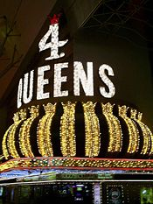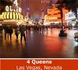
A Waiter in Drag: (to Chandler and Monica) Has someone taken your order yet?
Monica: Uh oh yeah, she did. Uh, he did. (To Chandler) She? (To the waiter) I’m-I’m sorry I’m new. I don’t…
Waiter in Drag: (To Chandler) Hm-mmm?
Chandler: Yeah, I just ordered a beer! (Pounds the table.)
Waiter in Drag: You’re straight. I get it. (Walks away.)
Monica: I still say that if we had called your dad we coulda gotten better seats.
Chandler: No! No! I don’t want him to know we’re here yet! I’m not sure I’m ready for that. And besides he’s not gonna be too happy to see me either.
Monica: Why not?!
Chandler: I don’t know if I’ve told you this, but he’s kinda tried to get in contact with me a lot over the last few years
Monica: What?!
Chandler: Yeah, he’s made phone calls, written letters, he even came to New York, but I always said I was too busy to see him. Y’know it’s all very Cats in the Cradle—I don’t want to get into it. (The show starts.) Here we go.
get into sth <口>谈论某话题/Cats in the Cradle: 钱德勒谈起了他和父亲的关系，说到了哈里 查普林的名歌《摇篮里的猫(Cats in the Cradle)》。这首歌主要讲述了父子之间的问题：孩子小的时候希望和爸爸一起玩球，但爸爸总是以“改天吧”拒绝；然后孩子逐渐长大，毕业工作，偶尔才回来看望父亲，父亲希望孩子多陪他聊聊天，但孩子也总是说“改天吧”/ "Cat's in the Cradle," is a folk rock song by American singer(songwriter) Harry Chapin. It appeared on Chapin's 1974 album Verities & Balderdash.It was written by Harry's wife Sandy, a poet and writer, long before the birth of their son Joshua. When Sandy showed it to Harry, he had only casual(adj.不经意的) interest. After Joshua's birth, Harry realized just how much the song meant to him and, after reworking the song, eventually recorded it. The song became the best known of Harry's work and a staple(n.代表作) for folk rock music.
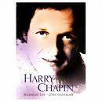
Announcer: Ladies and gentlemen please welcome the incomparable Helena Handbasket!
incomparable adj.无与伦比的
(There’s applause as Helena turns around and it’s Kathleen Turner.)
Mary Kathleen Turner (born June 19, 1954) is an Academy Award-nominated American actress. She came to fame during the 1980s, after roles in the Hollywood films Body Heat, Romancing the Stone and Prizzi's Honor.
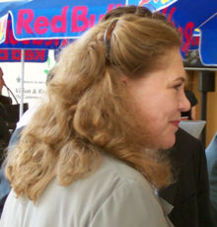
Helena: Hello darlings.
Chandler: And there’s daddy!
Commercial Break
[Scene: The Porsche, they have pulled over and are awaiting the cop to come talk to them.]
Rachel: Okay. Switch places with me! Switch places with me! Come on! I’ll go under, you go over!
Ross: Yeah, I’ll get right on that.
Rachel: Oh come on Ross!! (She tries to switch places with him and goes under his leg.)
Ross: No Rach! Come on! No-no! Yeah, I’m sure we won’t get arrested for this.
(She sits back up as the policeman approaches. She undoes her top button.)
Rachel: (sexily) Hi officer, was I going a little too fast?
Ross: Oh my God.
Policeman: Can I see your license please?
license n.驾照
Rachel: Oh yes, absolutely! Y’know, it’s weird uh, but I had a dream last night where I was stopped by a policeman. And then he uh…well I probably shouldn’t tell you the rest.
Ross: He gave you a big fat ticket?
Policeman: Your license?
Rachel: (handing it to him) Yes. Here you go Officer uh, Handsome.
Policeman: That’s Hanson.
Rachel: Oops sorry, my mistake.
Ross: Dear Lord!!
Policeman: Wow!
Ross: Here it comes.
Policeman: This is a great picture.
Rachel: Really?! You think so? Y’know, I had just rolled out of bed.
Policeman: Yeah? Well you look phenomenal.
Ross: Well she should, it was taken ten years ago!
Rachel: Y’know you’re-you’re probably wondering about the old date on there.
Policeman: Yes I am.
Rachel: Yeah.
Policeman: You’re an Aquarius, huh?
Aquarius n.水瓶座
[Horoscope英语课]
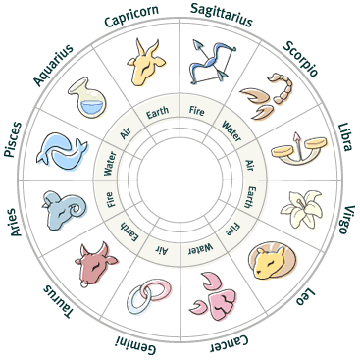

[1] Capricorn (Dec.23 - Jan.19)
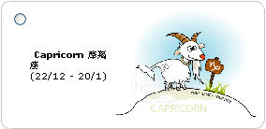
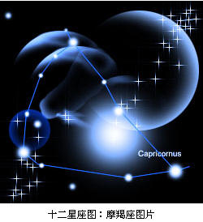
[2] Aquarius (Jan.20 – Feb.18)
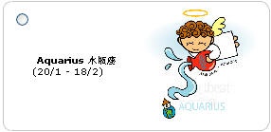
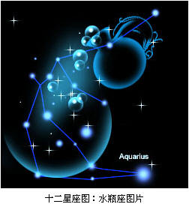
[3] Pisces (Feb.19 – Mar.20)
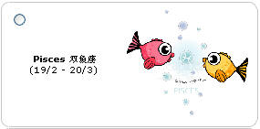
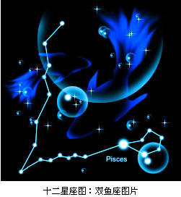
[4] Aries (Mar.21 – Apr.20)
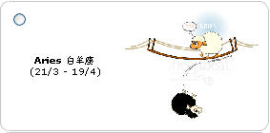
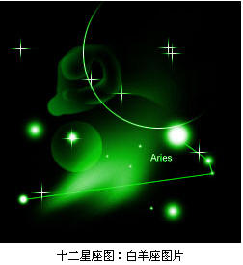
[5] Taurus (Apr.21 – May.20)
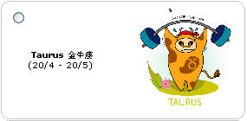
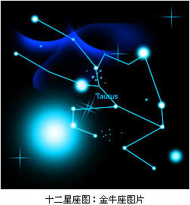
[6] Gemini (May.21 – Jun.21)
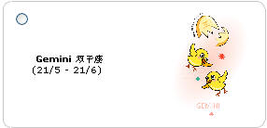
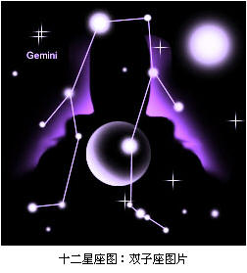
[7] Cancer(Jun.22 – Jul.22)
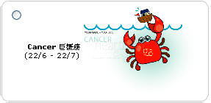
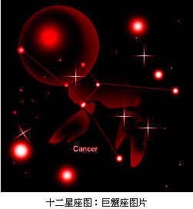
[8] Leo (Jul.23 – Aug.22)
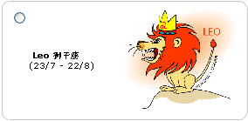
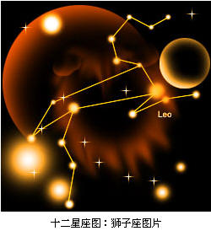
[9] Virgo (Aug.23 – Sep.22)
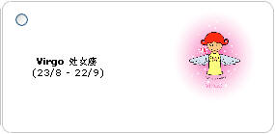
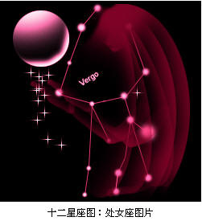
[10] Libra (Sep.23 – Oct.22)
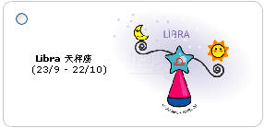
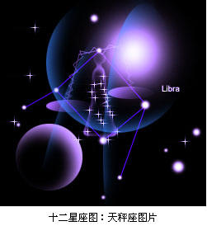
[11]Scorpio (Oct.23 – Nov.21)
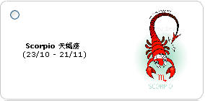
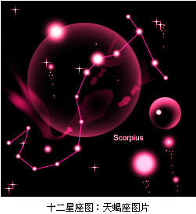
[12] Sagittarius(Nov.22 – Dec.21)
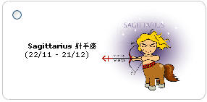
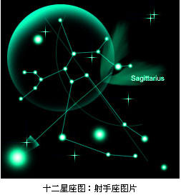
Rachel: I bet you’re a Gemini.
Policeman: Nope.
Rachel: Taurus?
Policeman: Nope.
Rachel: Virgo?
Policeman: Nope.
Rachel: Sagittarius?
Policeman: Yep.
Rachel: I knew it! I knew it, ahh….
Policeman: Well I tell you what…
Rachel: Yeah?
Policeman: You’re not gonna speed anymore right?
speed v.超速
Rachel: I won’t speed.
Policeman: And you promise you’ll get this taken care of right away?
Rachel: I promise.
Policeman: And in the meantime you better let him drive. Does he have a license?
Rachel: Yeah!
Policeman: Can he handle the stick?
stick <汽>手动挡车型
Rachel: Oh well…
Ross: I can handle the stick!!
[Scene: 4 Queens Club, Helena Handbasket is singing.]
Helena: I feel pretty. Oh so pretty. I feel pretty and witty and…(She holds the mike out to the audience.)
witty adj.诙谐的 机智的
All: Gay!
Monica: That can’t be your father.
Chandler: Believe me, I’ve been saying that for years. Oh my God!
Monica: What?
Chandler: That’s Mr. Girabaldi playing the piano.
Helena: (singing) For I’m loved by a pretty wonderful boy! (Applause.) Hello! And welcome to the show. I see some of our regulars in the audience. And a couple of irregulars. (He starts going into the audience.)
regular <口>老顾客 老客户[eg: The barman gave free drinks to the regulars at Christmas]
Chandler: He’s coming into the audience. He’s coming into the audience.
Monica: Relax! You’ll be fine. (Chandler exhales and turns off the table light.) Oh much better. You’re invisible now.
Helena: (standing at a table and asking the guy sitting there) Where are you from?
Guy: Bakersfield.
Helena: I’m sorry? (Holds out the mike.)
Guy: Bakersfield!
Helena: No-no I heard! I’m just sorry.
Chandler: It can’t happen like this. Okay? I’ll meet you back at the hotel.
(He gets up to walk out, but Helena spots and stops him.)
Helena: (to Chandler’s back) Oh look, a standing ovation already! So early in the show. Oh turn around honey; let me see your pretty face. (He slowly turns around. Helena recognizes him.)
ovation n.热烈欢迎(或鼓掌)[eg: The show won a standing ovation]

standing ovation

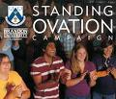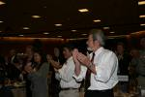
Monica: Can we have our drinks please?! Waiter—Uh, tress!
[Scene: Central Perk, Phoebe is sitting on the couch as Joey enters strutting.]
strut vi. 高视阔步 趾高气扬地走[eg: Eddie turned around and strutted back to them]

Joey: Hey Pheebs! (He sits down next to her.)
Phoebe: Hey!
Joey: Check it out. (He turns around, pulls down his pants, and shows Phoebe that he’s got panties on.) How much of a man am I?!
Phoebe: Wow! Nice! Manly and also kind of a slut.
manly adj.masculine
Joey: Y’know, I’m beginning to see what Jake was talking about.
Phoebe: Uh-huh.
Joey: The silk Feels really good!
Phoebe: Huh.
Joey: Yeah! And-and things aren’t as smashed down as I thought they were gonna be.
smash v.击溃 粉碎
Phoebe: That’s great Joe!
Joey: Yeah! And you have so many more choices than you do with men’s underwear!
Phoebe: Uh-huh.
Joey: Bikini, French cut, thong! And-and the fabrics! You’ve got cotton, silk, lace! And y’know what I’ve always wondered about?
French cut/fabric n.织物 布料
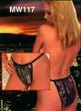
Phoebe: Hmm?
Joey: Pantyhose! Y’know? The way they start at your toe and go all the way up to here… (He mimed that and stops when he realized he went too far.) I should go take these off shouldn’t I?
pantyhose n.(女)连裤袜
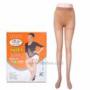
Phoebe: I think it’s important that you do.
(Joey agrees and heads to take them off.)
[Scene: 4 Queens Club, scene continued from earlier.]
Helena: So what’s your name?
Chandler: (resigning himself to his fate) Chandler. (He quickly sits down.)
resign to v.托付给
Helena: Chandler? What an unusual name! You must’ve had terribly fascinating parents.
terribly adv.十分地
Chandler: Oh, they’re a hoot.
hoot <俚>One that is hilariously funny[eg: Emmett, that skirt is a hoot!]
Helena: (To Monica) And who is your friend?
Monica: I’m-I’m Monica.
Helena: Monica! Where are you from?
Monica: New York.
Helena: I’m not very fond of New York. Queens I like. (Noticing Monica’s ring.) Ooh, what is this sparkle something! (Shows the audience who woos.) Honey! Huh?
Chandler: Actually Monica and I are engaged.
Helena: Really?! Congratulations. When’s the big day?
Monica: (looks at Chandler) In…in two weeks.
Helena: (disappointed) I see. Well, I wish you both a lifetime of happiness. (To a bald guy.) So you’re bald?
Chandler: Wait! Wait! We’d really love it if you could be there.
Helena: Really? (Looks at Monica who nods.)
Chandler: I know it would make me happy, ma’am.
Helena: Well I wouldn’t miss it for the world. Oh! I’m getting all misty here! You’d think I was having my legs waxed or something. (Goes back on stage.)
not for the world 无论如何也不/misty adj. 热泪盈眶 泪水迷蒙的[eg: misty eyes]

leg wax


Monica: (To Chandler) You okay?
Chandler: Yeah. Thanks for making me do this.
Helena: Before we go on with the show, I just want to say to the bride and groom how lucky they are to have found each other. In every life, a little rain must fall. Fortunately, in my life… (Four guys wearing rubber boots, shorts, hats, and nothing else carrying umbrellas run onto the stage.) (Singing) It’s raining men! It’s raining men!
rubber boot n.胶靴
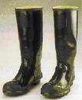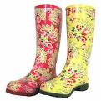
Chandler: (To Monica) When I was growing up I…played the one on the far left.
[Scene: The Porsche, cars are whizzing by and honking their horns on both sides very quickly as Ross creeps along.]
whiz vi.飕飕掠过 急驰[eg: The express train whizzed past the station] /creep v.以龟速前进 匍匐而行

Rachel：(Can’t stand the slow speed Ross is driving at) Ooh
Ross: I think you've had enough fun for today.
Rachel: Remind me to introduce you to someone!
Ross: Who?
Rachel: Fourth gear!!
fourth gear n.四档
(Suddenly a siren goes off.)
Ross: What?! What does he want?! I wasn’t doing anything!
Rachel: Well maybe he saw your hand slip briefly from the ten and two o’clock position.
Ross: Maybe it’s uh Sergeant Sagittarius coming back to flirt some more! Perhaps he didn't tarnish the badge enough. (They pull over.)
Sergeant n.警官/tarnish vt.使失去光泽 败坏 玷污(名誉等)[eg: The scandal tarnished his reputation]
Rachel: It’s a different guy!
(The policeman walks up.)
Ross: Good evening officer.
Policeman: Do you know how fast you were traveling back there?
Ross: Ah no. I don’t, but it could not have been more than sixty.
Policeman: You’re right. It was 37. (Rachel laughs.)
Ross: Really?
Policeman: Can I see your Iicense, pIease?
Ross: You're kidding, you’re not gonna give me a-a ticket for driving too slow are ya?
ticket <口>(给违反交通规则者等的)传票 罚单[eg: Harris got a ticket for speeding]
Policeman: That’s right.
Ross: You wanna help me out here?
Rachel: I'm sorry, what?
Ross: Can you do your Iittle thing that you did before?
Rachel: I don't think so. I don't think I want to tarnish his badge.
(There’s a pause as Ross gets suddenly flirtatious.)
flirtatious adj.调情的 卖俏的
Ross: Y’know of-officer I uh…I had the weirdest dream last night…
Rachel: Oh my God!
Policeman: Your license please.
Ross: (laughs) You don’t-you don’t want to hear about my dream Officer…Pretty?
Policeman: It’s Petty. (He grabs Ross’s license.) I’ll be right back with your ticket. (Walks back to his car.)
Rachel: (pause) You have a son!
Ross: I know. I know.
Ending Credits
[Scene: Central Perk, Joey is returning from having removed Rachel’s panties.]
Phoebe: Feel better?
Joey: Yeah! Much! Listen uh, not that I’m y’know insecure about my manhood or anything y’know, but I think I need to hook up with a woman like right now.
not that adv.倒不是/manhood n.masculinity
Phoebe: Yeah, I understand.
Joey: Yeah! Okay! (He notices a beautiful woman sitting behind the couch and goes to talk to her.) Hey! Hi!
Woman: Hi!
Joey: Y’know, you look familiar. Do I know you from somewhere?
Woman: I don’t think so.
Joey: Oh! Maybe it’s because I’m on television. I’m an actor on Days of Our Lives.
Woman: Wow!
Joey: Yeah.
Woman: Really?!
Joey: Hm-mmm.
Waitress: (to the woman) $4.50 please.
Joey: Oh, let me get this. (He takes out his wallet, but the panties come with it. The woman and waitress are shocked.) (Realizing) (To the woman) These are for you.(The woman frowns upon his behavior)
End

